**Predicting the Best Neighborhood for a Mexican Restaurant in Toronto.**

Victor Gbadamosi

January 06, 2021.

1. Introduction.
   1. Background

The cuisine of Toronto reflects Toronto's size and multicultural diversity. Different ethnic neighborhoods throughout the city focus on specific cuisines, such as authentic Chinese and Vietnamese which are found in the city's Chinatowns, Korean in Koreatown, Greek on The Danforth, Italian cuisine in Little Italy and Corso Italia, and Indian/Pakistani in Little India. Numerous other world cuisines are available throughout the city, including Portuguese, Hungarian, Japanese, and Caribbean. Toronto's large Jewish population has also ensured a variety of Jewish restaurants and delis, with varying adherence to kosher rules. In addition to ethnic cuisines, Toronto is also home to many fine dining establishments, and chain restaurants ranging from fast food to casual or upscale dining. Toronto is not known for a diversity of foods from street vendors, as there are numerous take-out restaurants.

* 1. Problem

In recent times, there has been rapid increase in the opening of restaurants in Toronto, Canada. However, different restaurants have held a lot of customers down due to good location, customer service, and great cuisines to try their taste buds on. So, the restaurant scene has brought in competition into the market, and start-ups are looking for a place to open up a Mexican restaurant in Toronto.

The question now is where is the best location to open up that Mexican restaurant? As time goes on, the city's population that is currently around 3.5 million will probably increase to about 7 million in the space of 50 years. So, in the bid to develop a Mexican restaurant, which will require a lot of money and hard work to set up, which of the neighborhoods in Downtown Toronto would represent the best option?

* 1. Interest

A wealthy and successful restaurant owner from Mexico is eager to expand his business into Toronto. He wants to build a mouth-watering Mexican restaurant that will serve and offer the full richness of Mexican culture and cuisine to the people of Downtown Toronto. Since Downtown Toronto is very competitive, the client needs insight from data from Toronto in order to decide in which neighborhood to establish this authentic Mexican restaurant.

1. Data acquisition and cleaning.
   1. Data sources.

The dataset that will be used is available on the Wikipedia page: <https://en.wikipedia.org/wiki/List_of_postal_codes_of_Canada:_M>. This dataset describes Toronto neighbourhood details alongside their postal codes. As discussed earlier, the focus of the project will be the Downtown Toronto neighborhoods which will be extracted and analyzed. The coordinates of the neighborhoods were also gotten from https://cocl.us/Geospatial_data.

The Foursquare API will be utilized to obtain the geographical location data for Downtown Toronto, and data will be used to explore the restaurant venues in the neighborhoods. The restaurants will provide the categories needed for the analysis and these will be used to determine the viability of the selected locations for the restaurant. The data from Wikipedia and Foursquare will be explored and analyzed by considering the restaurant venues in Downtown Toronto. The restaurants from the core of the city will be reviewed in terms of the types or categories of restaurants within a specific radius. The data will be utilized to come up with a frequency analysis for a Mexican eatery in Downtown Toronto, and to come up with the best choices of neighborhoods for my client.

2.2 Data Cleaning.

Data downloaded were imported into the notebook and was cleaned to the desired state. However, the list of postal codes on the website contains all the postal codes in Canada, but the project is solely focused in the neighborhoods in Toronto. So, for easy sorting, postal codes beginning with M are located within the city of Toronto in the province of Ontario.

From the dataset, it was observed that there were some postal codes that were not assigned borough and neighborhood, so all those were dropped in the course of the analysis. After dropping the unassigned boroughs, the new number of rows in the dataframe was seen to 103. Also, after the cleaned list of postal codes was merged with the geodata, the dataframe was seen to have the total of ten (10) boroughs and 103 neighborhoods.

The geographical coordinates of Toronto are 43.6534817, -79.3839347. The map of downtown Toronto was then illustrated through the Folium library. The foursquare API was then used to explore the neighborhoods and segment them. After all the unique categories were collected from all the returned venues, 208 unique categories were recorded. At the end of everything, through clustering, each neighborhood was tagged with the top 15 most common venues where it was observed that only few neighborhoods had Mexican restaurants.

3 Exploratory data analysis

As stated under the data cleaning section, some postal codes were not assigned borough and neighborhood. The table 3.1 describes the preview of the dataframe before it was cleaned, while table 3.2 shows the preview of when it was cleaned.

|  | **Postal Code** | **Borough** | **Neighborhood** |
| --- | --- | --- | --- |
| **0** | M1A | Not assigned | Not assigned |
| **1** | M2A | Not assigned | Not assigned |
| **2** | M3A | North York | Parkwoods |
| **3** | M4A | North York | Victoria Village |
| **4** | M5A | Downtown Toronto | Regent Park, Harbourfront |

Table 3.1: Preview of the list of the postal codes before it was cleaned.

|  | **Postal Code** | **Borough** | **Neighborhood** |
| --- | --- | --- | --- |
| **0** | M1B | Scarborough | Malvern, Rouge |
| **1** | M1C | Scarborough | Rouge Hill, Port Union, Highland Creek |
| **2** | M1E | Scarborough | Guildwood, Morningside, West Hill |
| **3** | M1G | Scarborough | Woburn |
| **4** | M1H | Scarborough | Cedarbrae |

Table 3.2: Preview of the list of postal codes after it was cleaned.

The latitude and longitude values were gotten from the website: <https://cocl.us/Geospatial_data>. Since the location for each postal code has its own coordinate, i.e. latitude and longitude, the two dataframes were merged and the result is shown in table 3.3. Table 3.4 shows the preview of the Downtown Toronto borough.

|  | **PostalCode** | **Borough** | **Neighborhood** | **Latitude** | **Longitude** |
| --- | --- | --- | --- | --- | --- |
| **0** | M1B | Scarborough | Malvern, Rouge | 43.806686 | -79.194353 |
| **1** | M1C | Scarborough | Rouge Hill, Port Union, Highland Creek | 43.784535 | -79.160497 |
| **2** | M1E | Scarborough | Guildwood, Morningside, West Hill | 43.763573 | -79.188711 |
| **3** | M1G | Scarborough | Woburn | 43.770992 | -79.216917 |
| **4** | M1H | Scarborough | Cedarbrae | 43.773136 | -79.239476 |

Table 3.3: Merged list of postal codes with their coordinates.

|  | **PostalCode** | **Borough** | **Neighborhood** | **Latitude** | **Longitude** |
| --- | --- | --- | --- | --- | --- |
| **0** | M4W | Downtown Toronto | Rosedale | 43.679563 | -79.377529 |
| **1** | M4X | Downtown Toronto | St. James Town, Cabbagetown | 43.667967 | -79.367675 |
| **2** | M4Y | Downtown Toronto | Church and Wellesley | 43.665860 | -79.383160 |
| **3** | M5A | Downtown Toronto | Regent Park, Harbourfront | 43.654260 | -79.360636 |
| **4** | M5B | Downtown Toronto | Garden District, Ryerson | 43.657162 | -79.378937 |

Table 3.4: Preview of the Downtown Toronto borough.

The map of downtown Toronto is shown in the figure below and the markers for each neighbourhood is attached to it. the neighbourhoods include, Rosedale, St. James Town, Cabbagetown, Church and Wellesley, Regent Park, Harbourfront, Garden District, Ryerson, CN Tower, King and Spadina, Railway Lands, Stn A PO Boxes, First Canadian Place, Underground city, Christie, Queen's Park, Ontario Provincial Government.

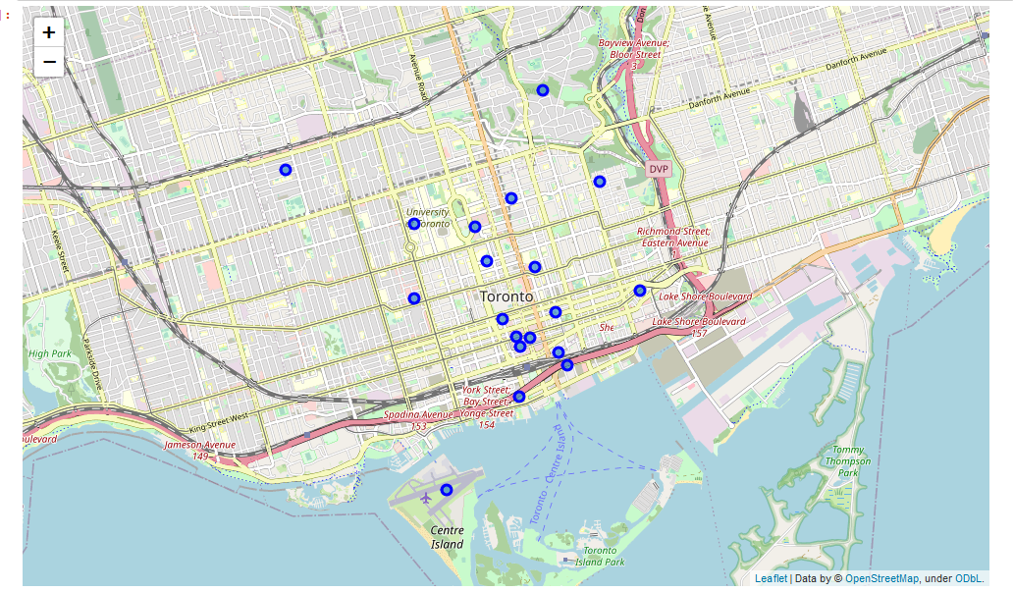

Fig 3.1: Map of Downtown Toronto.

4. Result

This section describes the result gotten before clustering and after clustering. Seventeen (17) neighbourhoods were illustrated into 5 different clusters, and they were tagged along with 15 most common venues/restaurants. Table 4.1 shows the preview of the table before clustering. However, because of the large size of the dataframe, only a part of it will be displayed. Tables 4.2, 4.3, 4.4, 4.5, 4.6 represent the preview of the table after clustering. However, the views are shown in the project notebook.

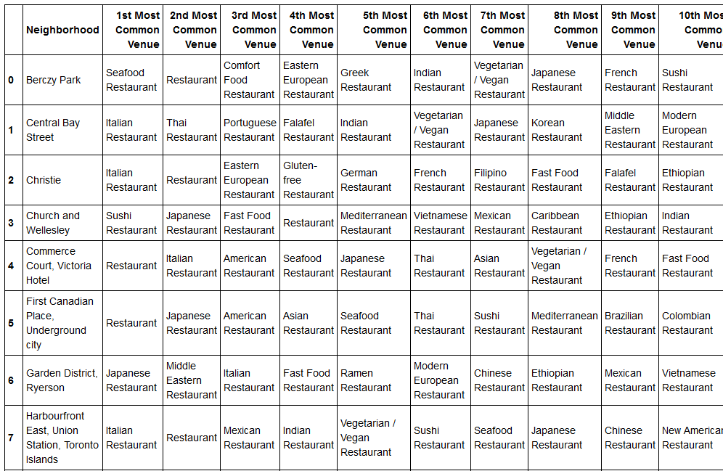

Table 4.1: Preview of the dataframe before clustering.

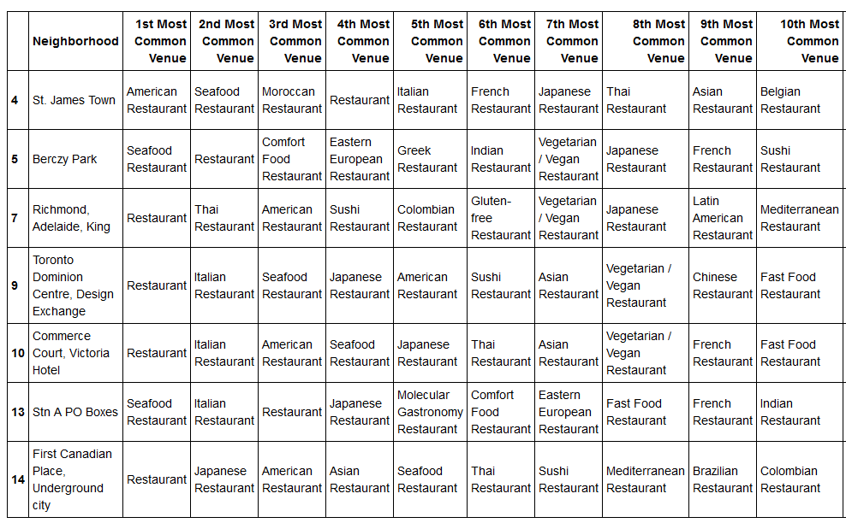

Table 4.2: Preview of cluster 1 dataframe after clustering.

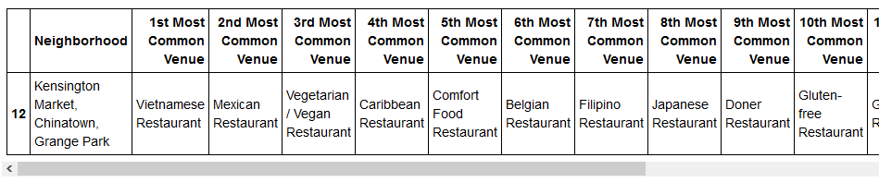

Table 4.3: Preview of cluster 2 dataframe after clustering.

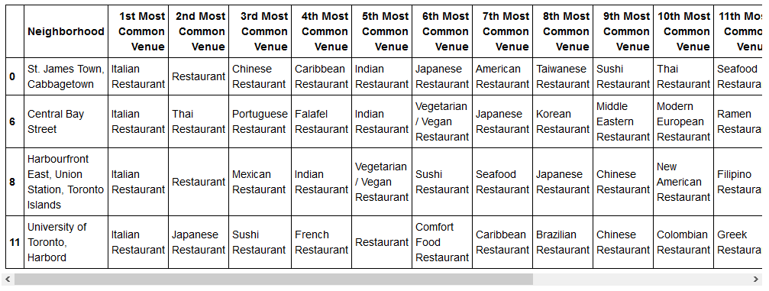

Table 4.4: Preview of cluster 3 dataframe after clustering.

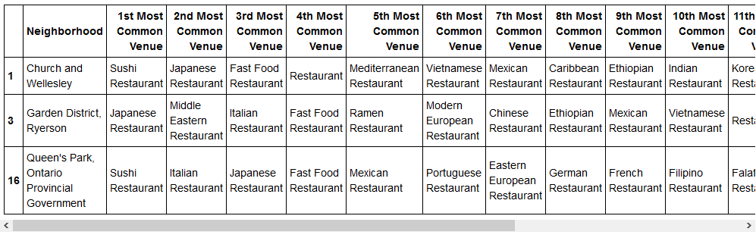

Table 4.5: Preview of cluster 4 dataframe after clustering.

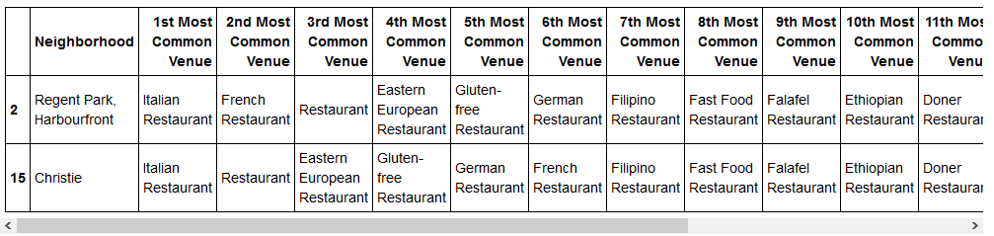

Table 4.6: Preview of cluster 5 dataframe after clustering.

5. Observations and Recommendations.

Sixteen (16) neighbourhoods were used to test and the following observations were made.

1. Most neighborhoods have Italian restaurants.
2. Italian restaurants were one of the top three (3) venues that were visited for neighbourhoods that had them, meaning so many people enjoyed their cuisines.
3. Only five (5) neighborhoods have Mexican restaurants, meaning there are not so many set-ups there.
4. None of the Mexican restaurant falls under the 1st most common venue.

Since the most visited restaurant is the Italian restaurant, it will be compared with the neighborhoods that have Mexican restaurants.

Neighborhoods that have Italian restaurant with their positions on the most common venue are 11 in total and they include:

1. Central Bay Street – 1st
2. Christie – 1st
3. Commerce Court, Victoria Hotel – 2nd
4. Garden District, Ryerson – 3rd
5. Harbourfront East, Union Station, Toronto Islands – 1st
6. Queen's Park, Ontario Provincial Government – 2nd
7. Regent Park, Harbourfront – 1st
8. St. James Town – 5th
9. St. James Town, Cabbagetown – 1st
10. Stn A PO Boxes – 2nd
11. Toronto Dominion Centre, Design Exchange – 2nd

Neighborhoods that have Mexican restaurant are 5 in total and they include:

1. Church and Wellesley – 7th
2. Garden District, Ryerson – 9th
3. Harbourfront East, Union Station, Toronto Islands – 3rd
4. Kensington Market, Chinatown, Grange Park – 2nd
5. Queen's Park, Ontario Provincial Government – 5th

**Recommendations: Since the client is looking for a best location to set up a Mexican restaurant, and only three (3) neighborhoods are without Italian and Mexican restaurants, the client would be advised to set up where people will always be present to hangouts. Therefore, the best location will be the Berczy Park to set up the Mexican restaurants.**

6. Conclusions

I was able to achieve the desired purpose of the analysis by giving the client the best location to set up his Mexican restaurant which is the Berczy Park.